Aleks Murauskas

260718389

ECSE 416

Test 3

Question 1:

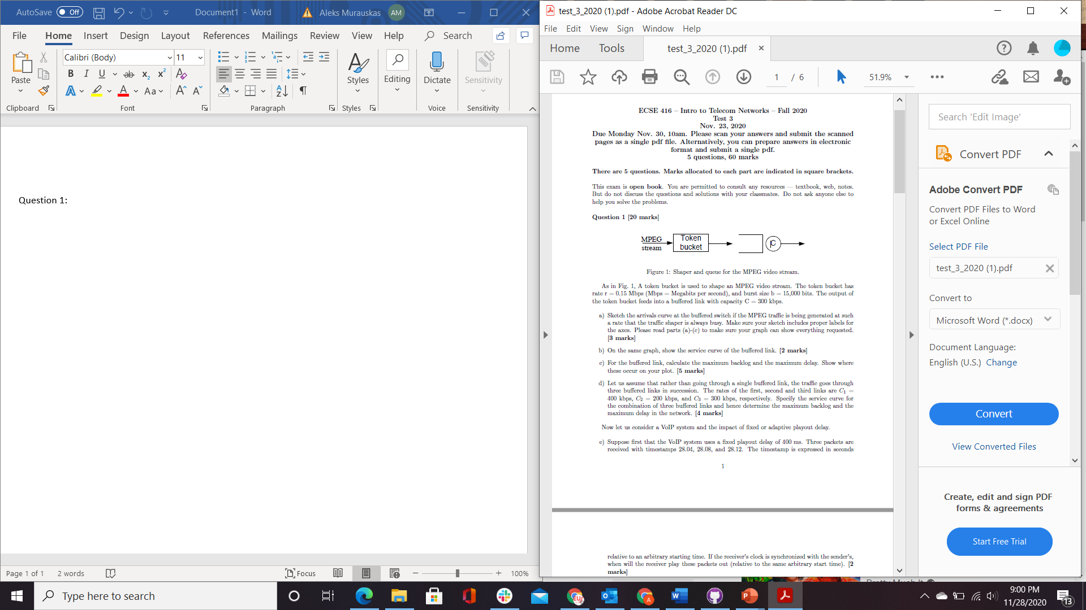

As in Fig. 1, A token bucket is used to shape an MPEG video stream. The token bucket has rate r = 0.15 Mbps (Mbps = Megabits per second), and burst size b = 15,000 bits. The output of the token bucket feeds into a buffered link with capacity C = 300 kbps.

1. Sketch the arrivals curve at the buffered switch if the MPEG traffic is being generated at such a rate that the traffic shaper is always busy. Make sure your sketch includes proper labels for the axes. Please read parts (a)-(c) to make sure your graph can show everything requested.

r average rate = 150,000 bps = 150 kbps

b Bucket size = 15,000 bits =15 kbits

R = 300 kbps = 300,000 bps = 300 kbps

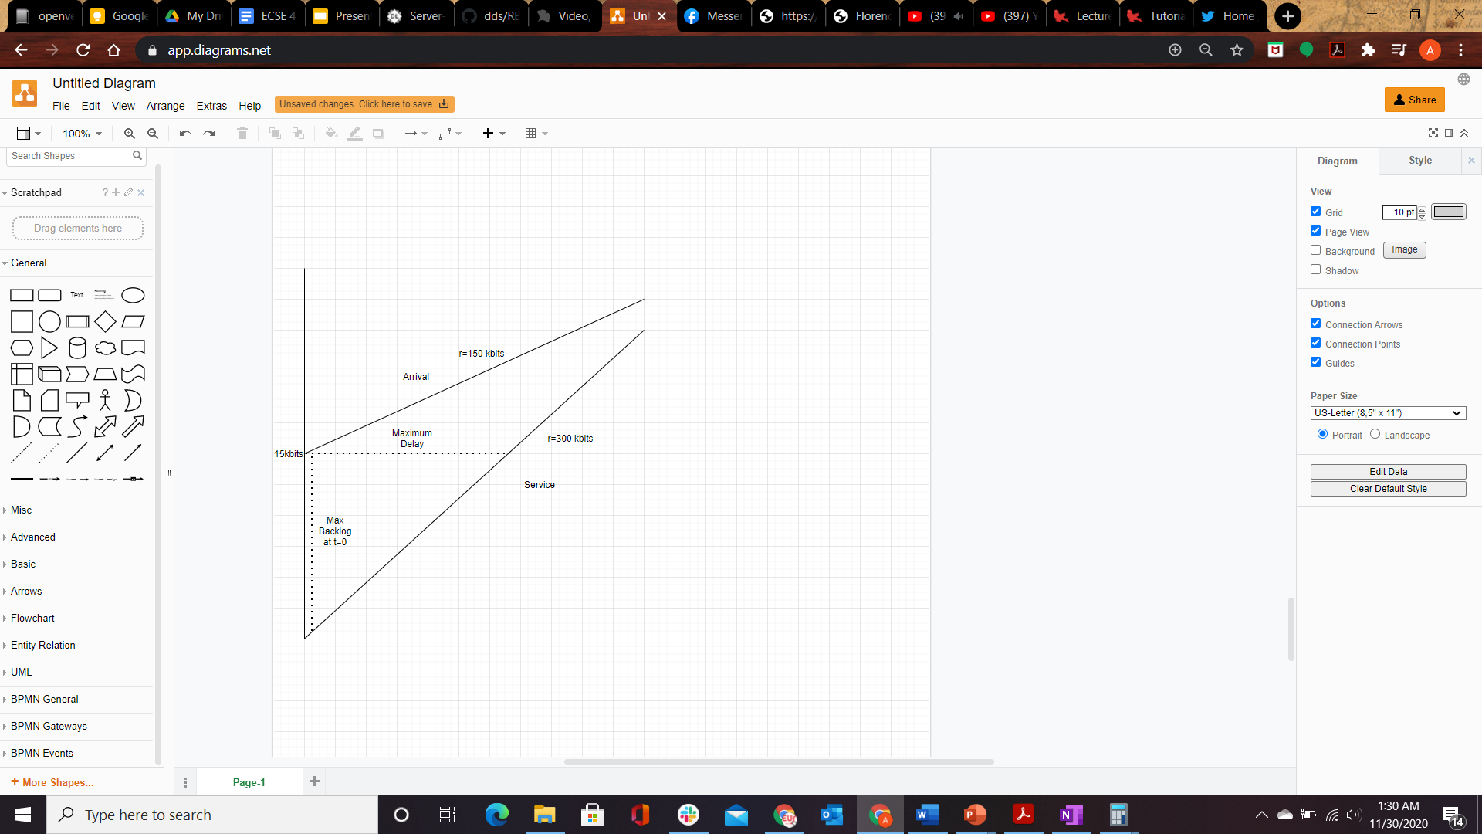

1. On the same graph, show the service curve of the buffered link
2. For the buffered link, calculate the maximum backlog and the maximum delay. Show where these occur on your plot.
3. Let us assume that rather than going through a single buffered link, the traffic goes through three buffered links in succession. The rates of the first, second and third links are C1 =400 kbps, C2 = 200 kbps, and C3 = 300 kbps, respectively. Specify the service curve for the combination of three buffered links and hence determine the maximum backlog and the maximum delay in the network.

Since C2 Bottlenecks the sequential links, 200 kbps is the effective rate of the whole system.

Now let us consider a VoIP system and the impact of fixed or adaptive playout delay.

1. Suppose first that the VoIP system uses a fixed playout delay of 400 ms. Three packets are received with timestamps 28.04, 28.08, and 28.12. The timestamp is expressed in seconds relative to an arbitrary starting time. If the receiver's clock is synchronized with the sender's, when will the receiver play these packets out (relative to the same arbitrary start time).

Packets plat out at

1. The receiver changes to an adaptive playout mechanism. There is a silence period, and then a sequence of packets is received with timestamps 40.05, 40.07, 40.09. Prior to this burst, the average measured delay was 50 ms and the average deviation was 5ms. The measured delay for the first packet in this burst is 60ms. Suppose the VoIP receiver does one update of the adaptive playout parameters before playing out the sequence. It uses EWMAs with constants a = 0.1 and B= 0.1 . When calculating the playout time, the average delay deviation is multiplied by K = 5. At what times are the three packets played out?

Question 2:

Suppose there are 6 classes of traffic: A, B, C, D, E, F. In your design below, you have access to weighted fair queuing (WFQ) scheduling mechanisms and strict priority queuing (SPQ) mechanisms (in the latter one input always has priority over the other). The outgoing link has capacity 10 Mbps. Suppose you wish to satisfy the following requirements:

* Class A should always have priority over all other classes.
* Classes B and C should always have priority over classes D, E, and F.
* Class B should be allocated 3 times as much bandwidth as class C.
* Class D should be allocated 5 times as much bandwidth as class F.
* Class E should be allocated 4 times as much bandwidth as class F.

1. Assign each traffic class into one queue and draw a diagram to describe the queuing discipline. (Hint: you may need multi-level scheduling, where the output of one queue is the input of another.)

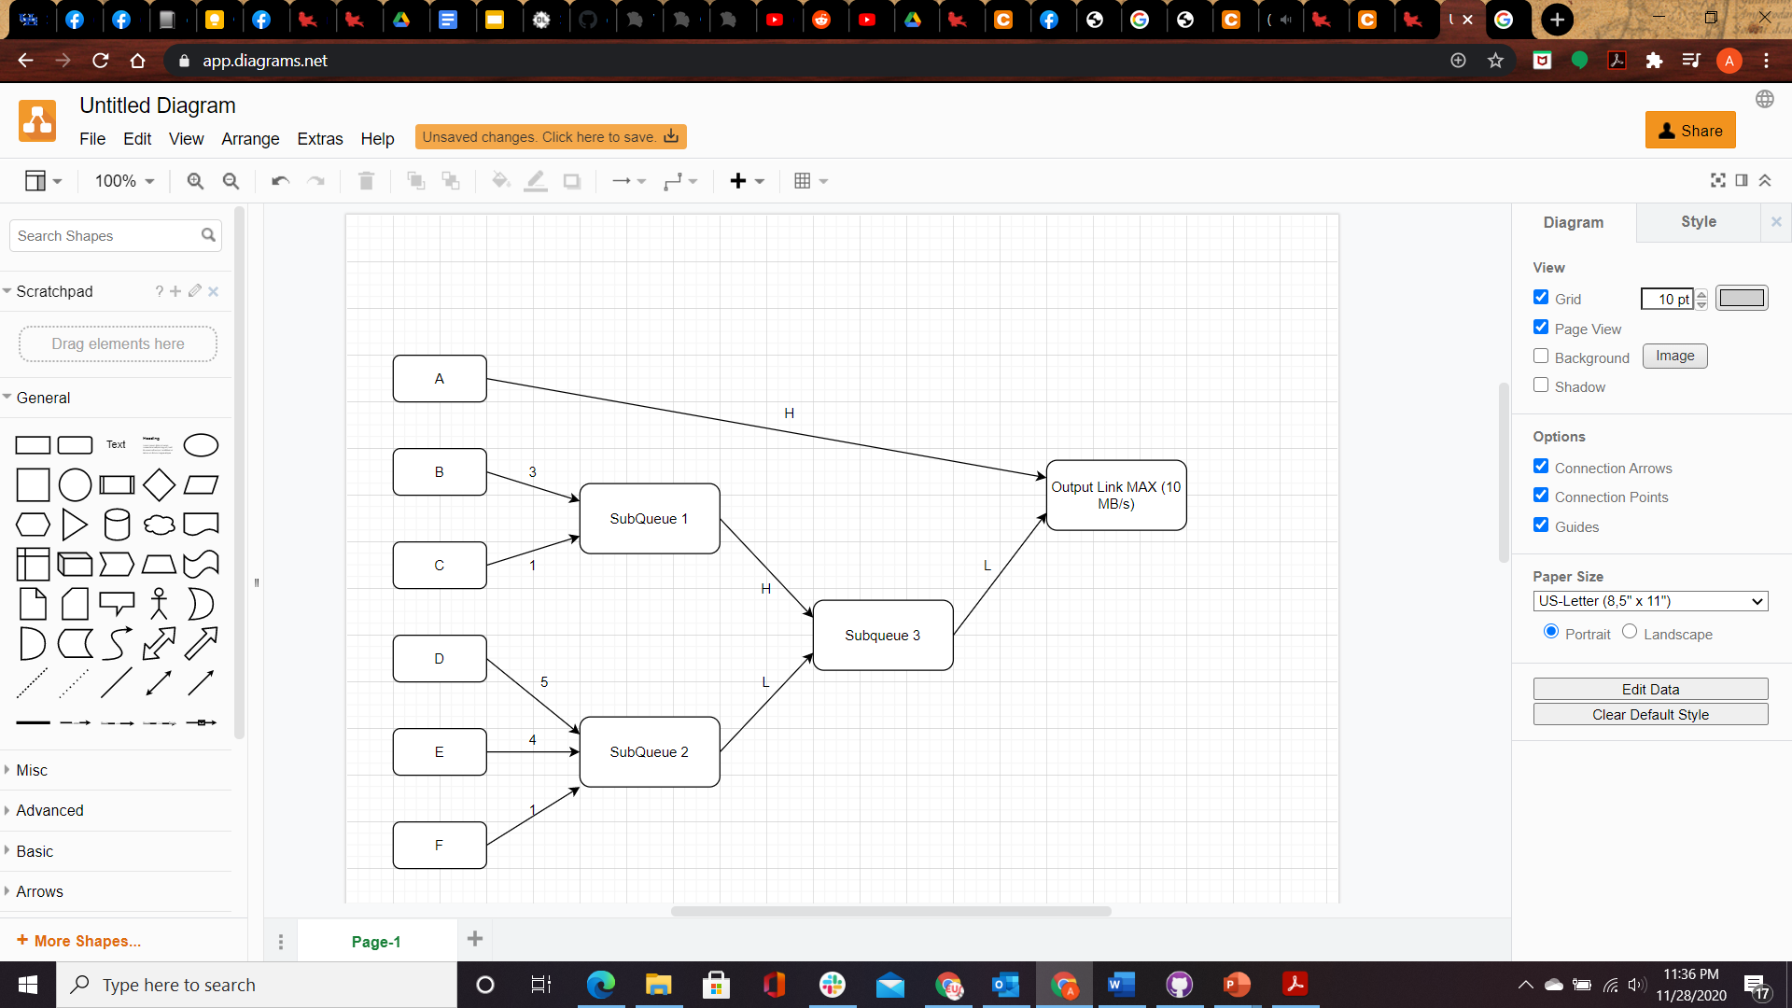

1. Complete the following table for this queuing system. Recall that the output rate of the entire link is 10 Mb/s.

Output Rates

|  |  |  |  |  |  |
| --- | --- | --- | --- | --- | --- |
| A | B | C | D | E | F |
| 2 | 6 | 2 | 0 | 0 | 0 |
| 1 | 1 | 1 | 5 | 1 | 1 |
| 2 | 2 | 2 | 2 | 1.6 | 0.4 |

Test case One: 10-2=8, 8/4 = 2, B=3*2=6, C=2

Test Case 1= 10-1= 9, 9-2=7, 7/10 =.7, Assume Fair weighted iteration until E completes, When E =1, 1.25 has been transmitted for D and 0.25 has been transmitted for F. For a total of 1+1.25+0.25=2.5. 7-2.5 = 4.5

4.5/6 = 0.75, D=5*0.75, F=0.75.

D= 1.25+3.75= 5, F=0.25+0.75=1

Test Case 3: 10-2= 8, 8-4= 4, 4/10 = .4, D=5*.4, E = 4*.4, F=.4

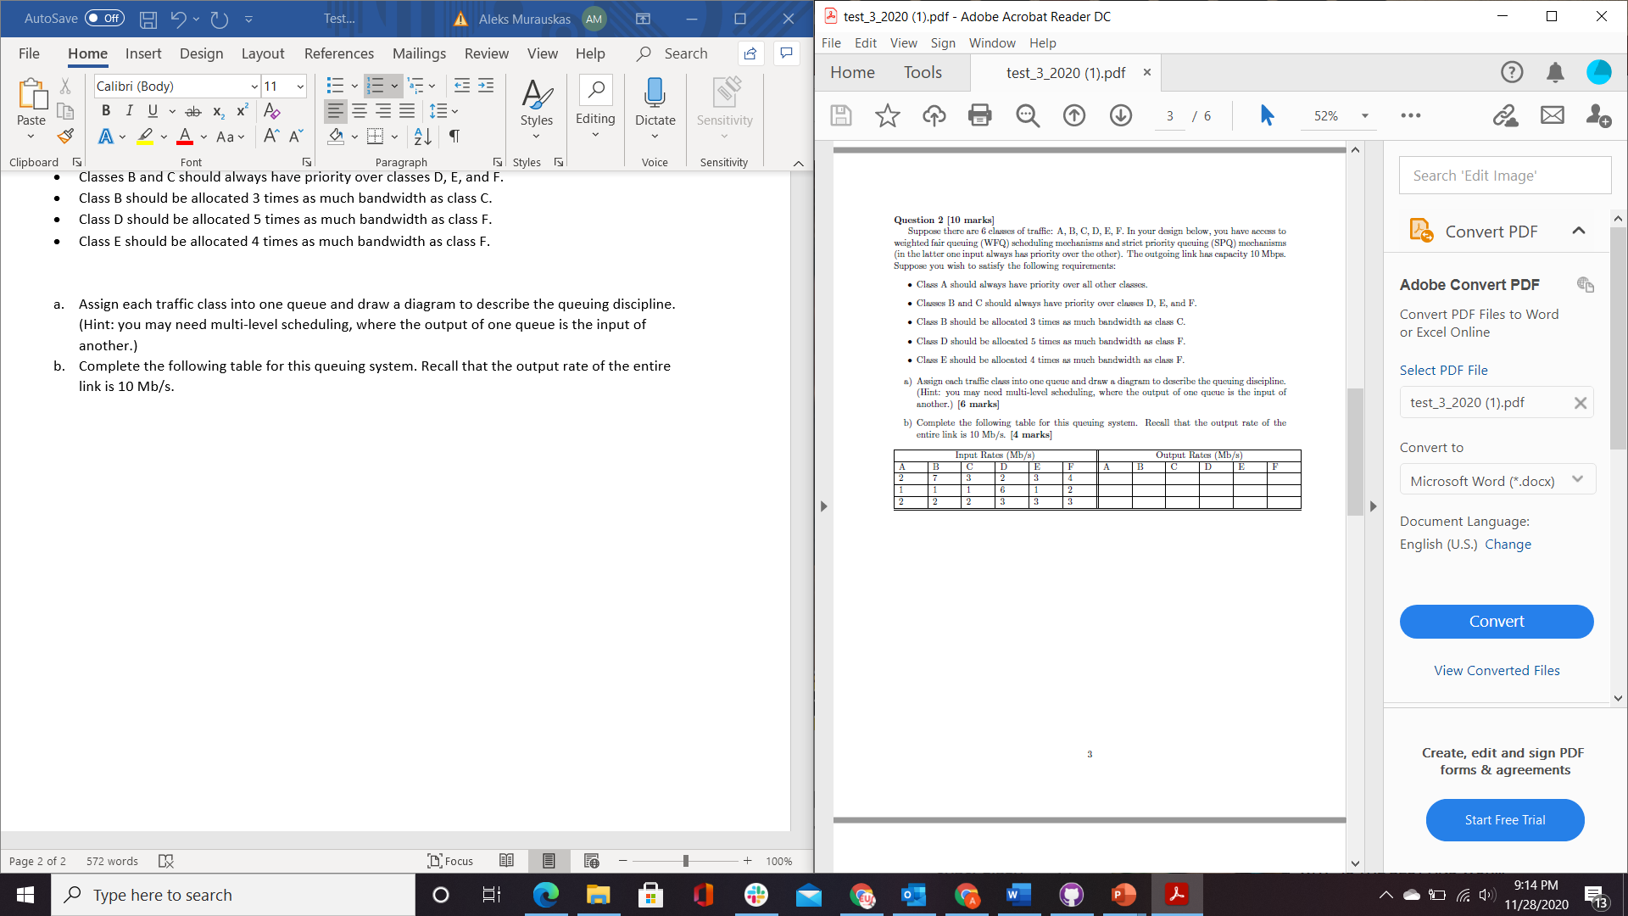

Question 3:

Packets are arriving from two flows at a WFQ scheduler. The arrival times and packet sizes given as follows:

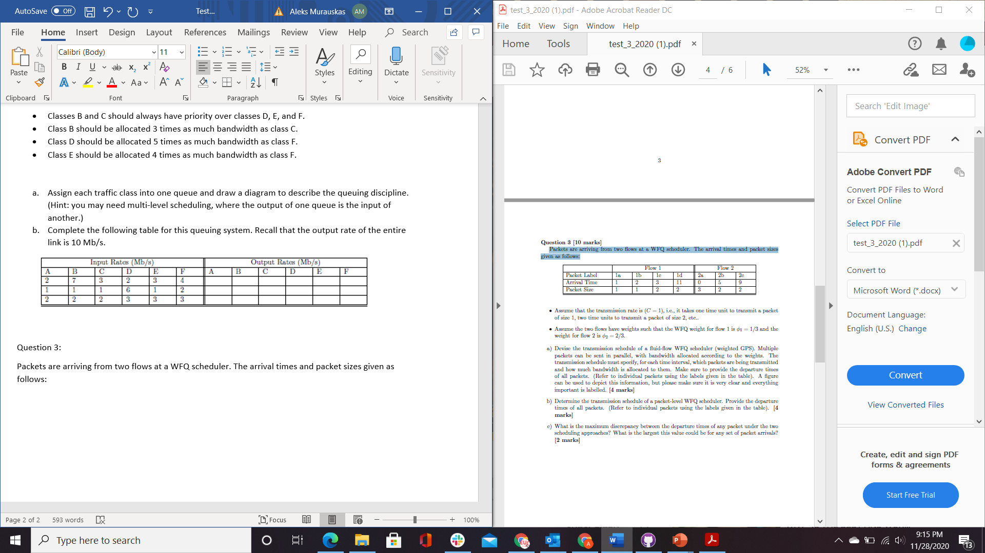

* Assume that the transmission rate is (C = 1), i.e., it takes one time unit to transmit a packet of size 1, two time units to transmit a packet of size 2, etc..
* Assume the two flows have weights such that the WFQ weight for flow 1 is and the weight for flow 2

1. Devise the transmission schedule of a fluid-flow WFQ scheduler (weighted GPS). Multiple packets can be sent in parallel, with bandwidth allocated according to the weights. The transmission schedule must specify, for each time interval, which packets are being transmitted and how much bandwidth is allocated to them. Make sure to provide the departure times of all packets. (Refer to individual packets using the labels given in the table). A figure can be used to depict this information, but please make sure it is very clear and everything important is labelled.

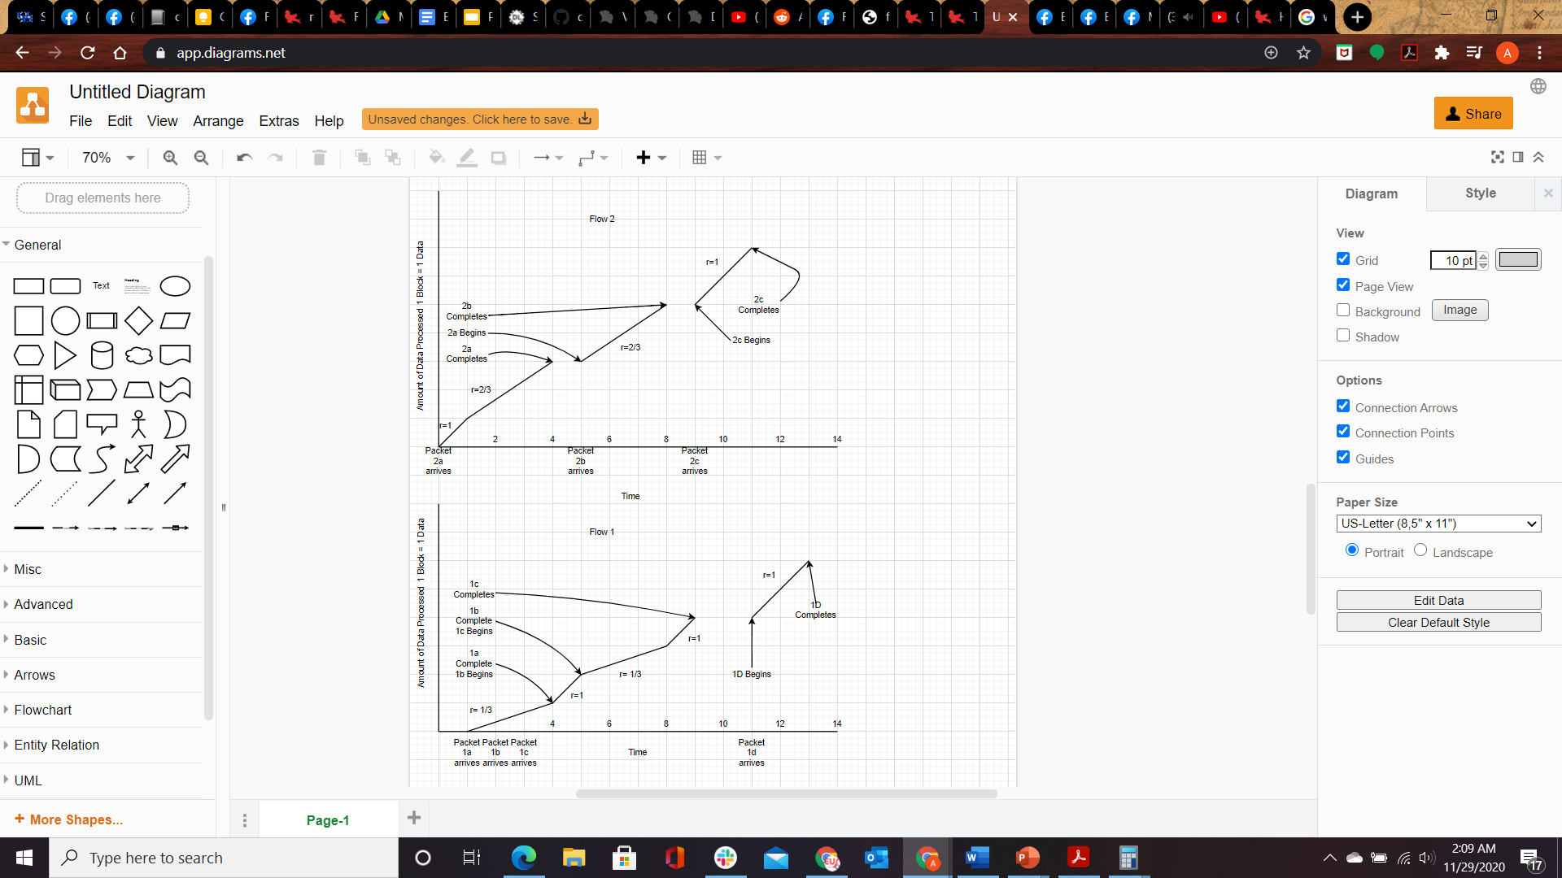

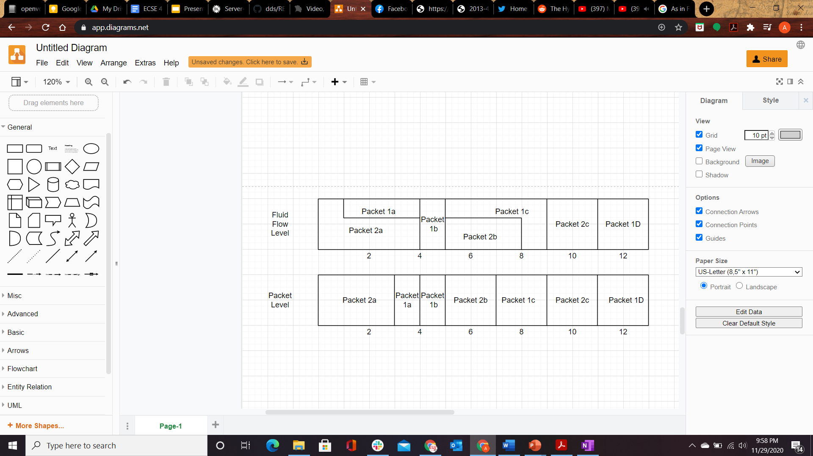

1. Determine the transmission schedule of a packet-level WFQ scheduler. Provide the departure times of all packets. (Refer to individual packets using the labels given in the table).



1. What is the maximum discrepancy between the departure times of any packet under the two scheduling approaches? What is the largest this value could be for any set of packet arrivals?

Comparing Packet Departure times

|  |  |  |  |
| --- | --- | --- | --- |
| Packet | Dept. Fluid Flow | Dept. Packet Level | Delta Time |
| 1a | 4 | 4 | 0 |
| 1b | 5 | 5 | 0 |
| 1c | 9 | 9 | 0 |
| 1d | 13 | 13 | 0 |
| 2a | 4 | 3 | 1 |
| 2b | 8 | 7 | 1 |
| 2c | 11 | 11 | 0 |

Question 4:

The iSLIP scheduling algorithm is a modification of PIM to avoid the randomness and improve

fairness. It involves the following three steps:

* Request: Each input sends a request to every output for which it has a queued cell
* Grant: If an output receives any requests, it chooses the one that appears next in a fixed, round-robin schedule starting from the highest priority element. The output notifies each input whether or not its request was granted. The pointer gi to the highest priority element of the round-robin schedule is incremented (modulo N) to one location beyond the granted input
* Accept: If an input receives a grant, it accepts the one that appears next in a fixed, round-robin schedule starting from the highest priority element. The pointer ai to the highest priority element of the round-robin schedule is incremented (modulo N) to one location beyond the accepted output.

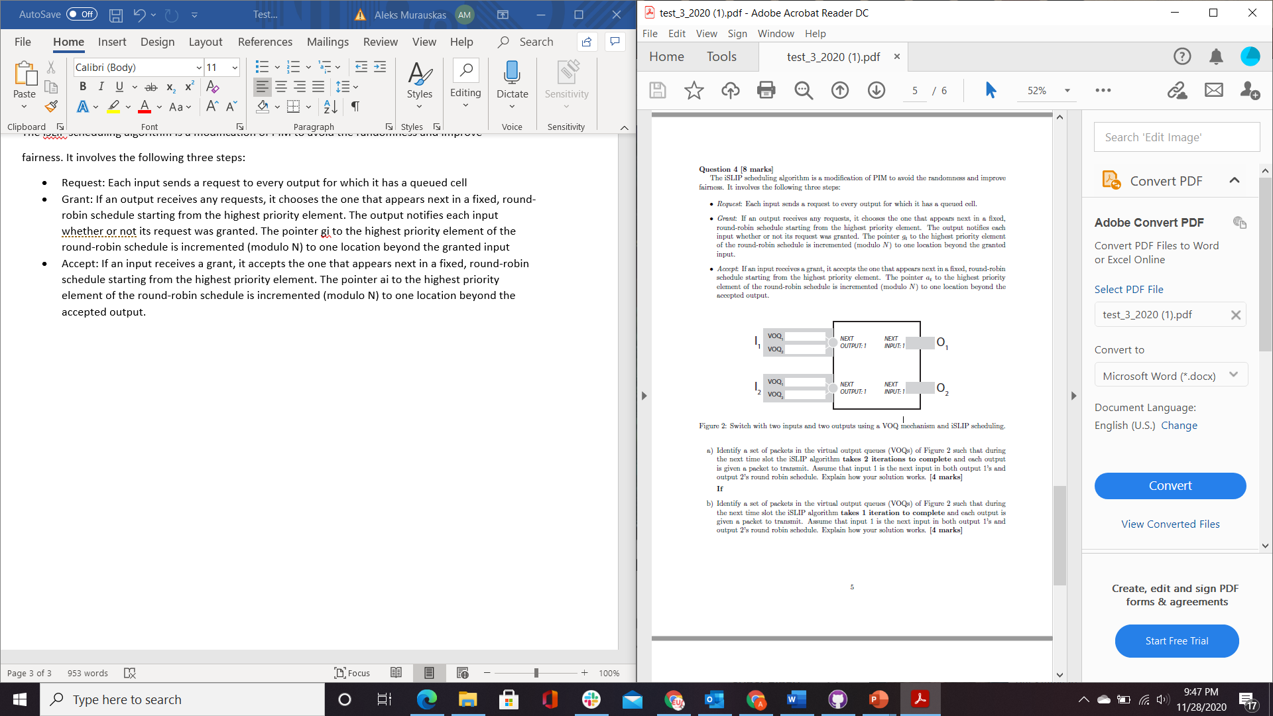

1. Identify a set of packets in the virtual output queues (VOQs) of Figure 2 such that during the next time slot the iSLIP algorithm takes 2 iterations to complete and each output is given a packet to transmit. Assume that input 1 is the next input in both output 1's and output 2's round robin schedule. Explain how your solution works.

In Iteration One, both inputs request to both outputs. The RR schedule will have both outputs grant I1, and I1 will send a packet from VOQ1 to O1. VOQ2’s packet request has been rejected. Iteration 2 Begins, and I1 is no longer able to send requests, the remaining request will be done with I2 and O2, The request is then completed and the algorithm terminates.

1. Identify a set of packets in the virtual output queues (VOQs) of Figure 2 such that during the next time slot the iSLIP algorithm takes 1 iteration to complete and each output is given a packet to transmit. Assume that input 1 is the next input in both output 1's and output 2's round robin schedule. Explain how your solution works.

There must be no clashing requests in order for the algorithm to only iterate once.

The above layout has no clashing. I1 sends one packet to O1 and I2 sends one packet to O2.

In the case even if O1 is scheduled to handle a I2 request, none have been sent, so it will grant I1. The same occurs vice versa with O2.

Question 5

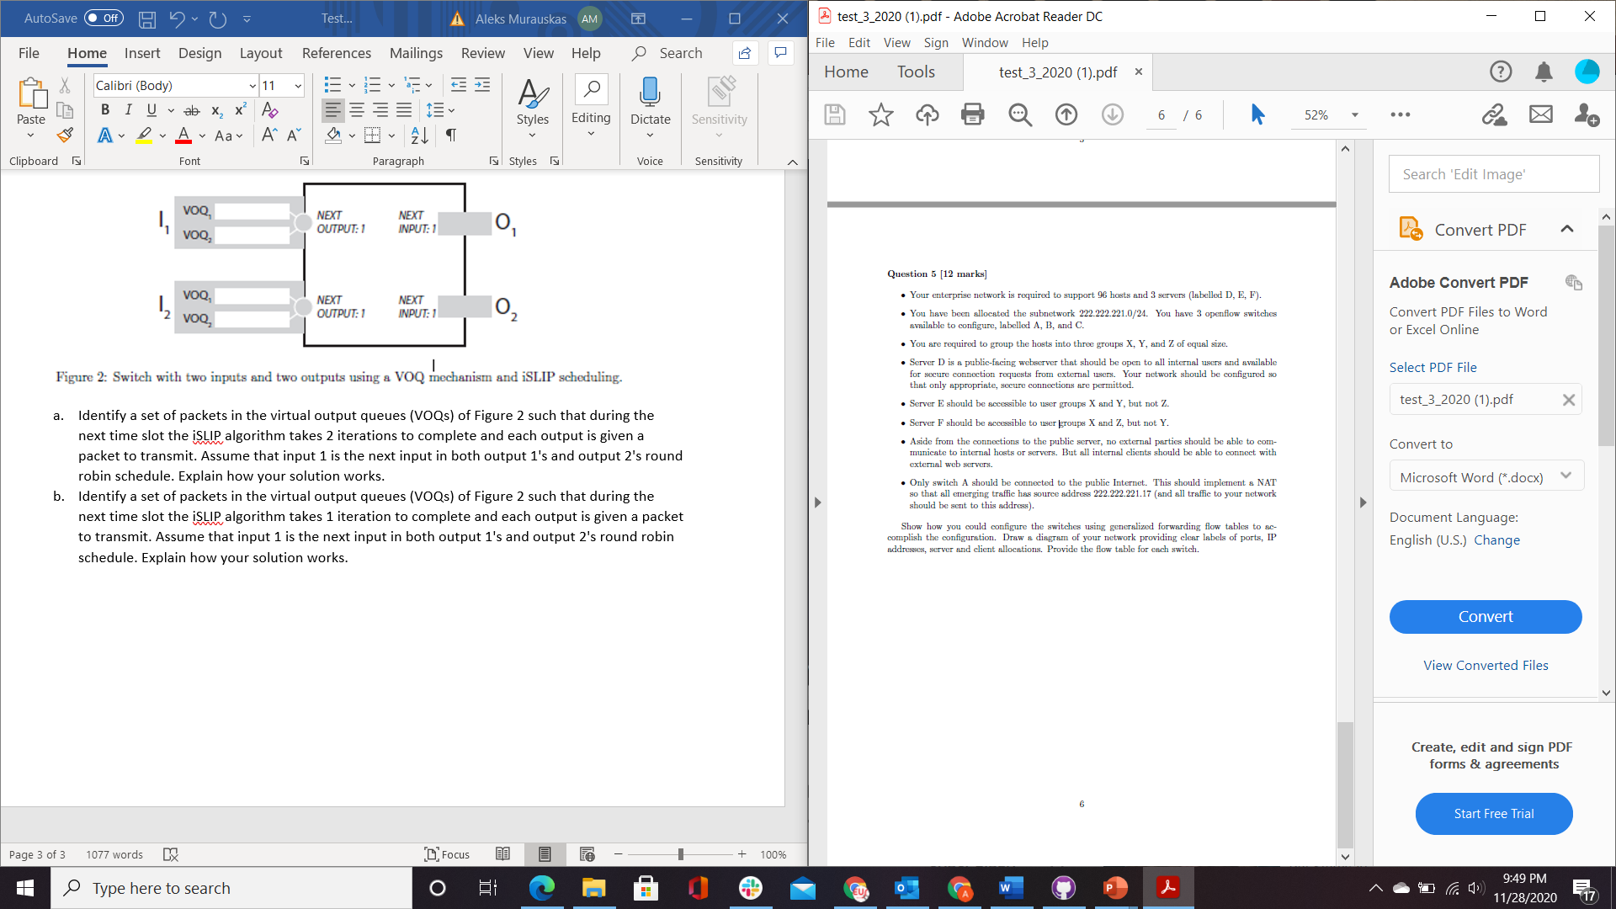

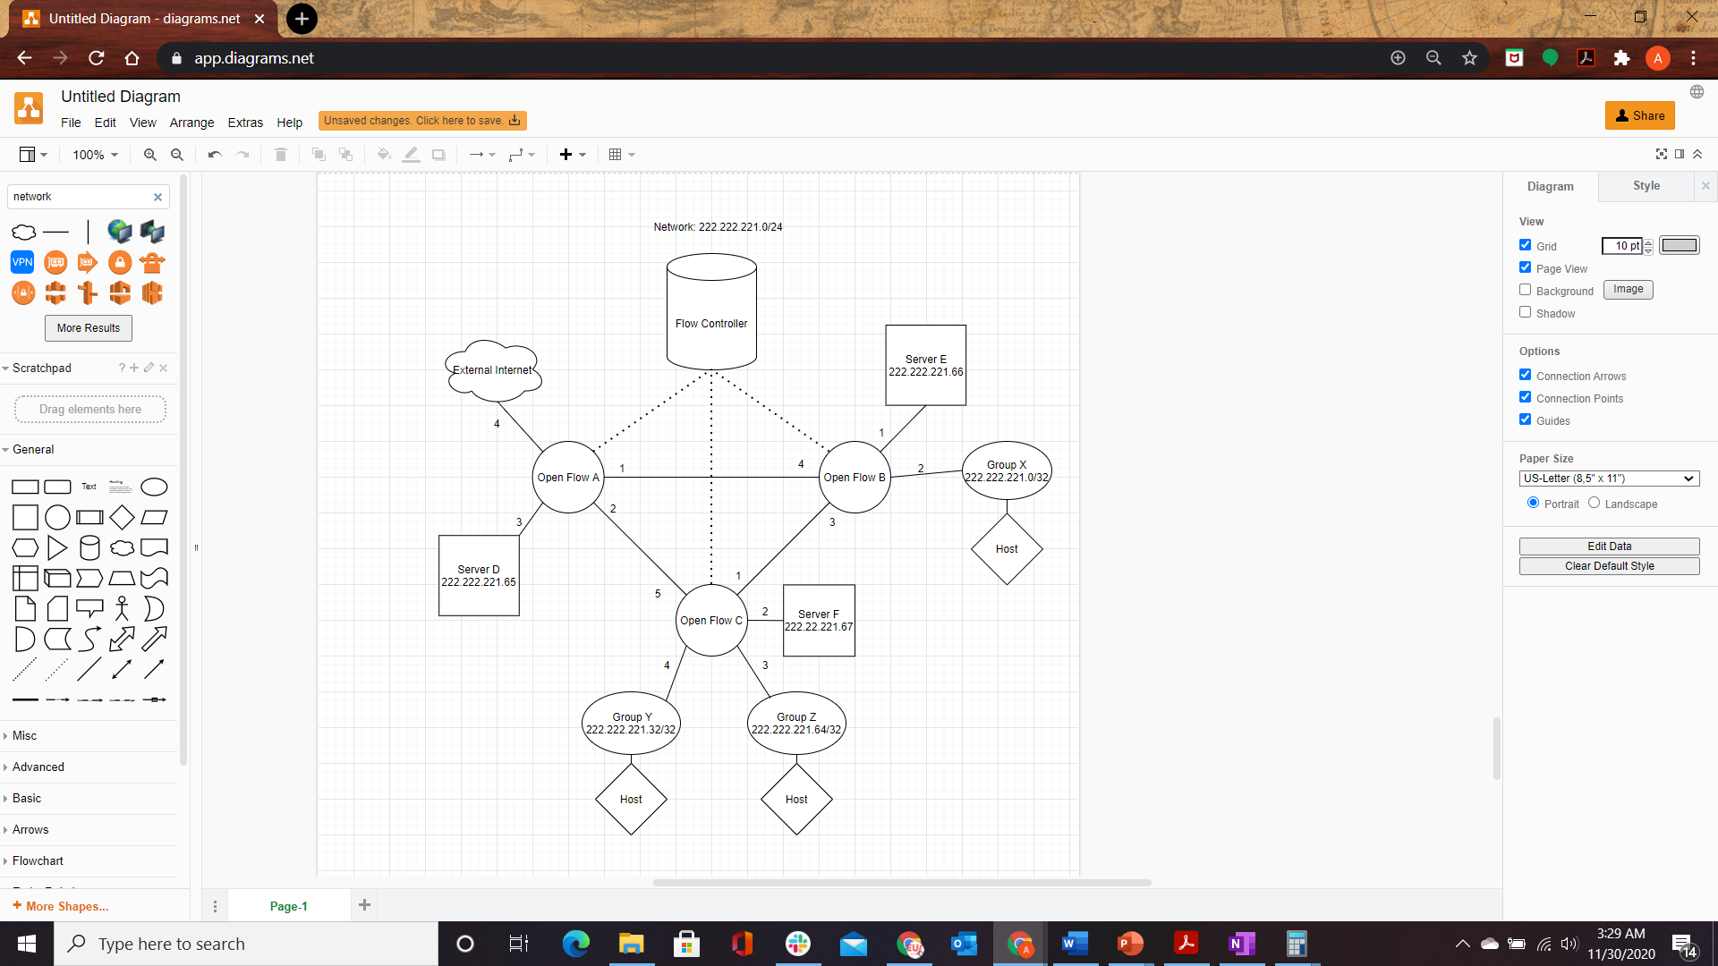

Flow Table: A

|  |  |
| --- | --- |
| Match | Action |
| IP src=222.222.221.*; IP dst = 222.222.221.0/32; | Forward(1) |
| IP src=222.222.221.32*; IP dst = 222.222.221.66 | Forward(1) |
| IP src= 222.222.221.*; IP dst = 222.222.221.32/32 | Forward(2) |
| IP src= 222.222.221.*; IP dst = 222.222.221.64/32 | Forward(2) |
| IP src= 222.222.221.* IP dst = 222.222.221.67 | Forward(2) |
| IP src=222.222.221.*; IP dst = 222.222.221.65; | Forward(3) |
| IP Src External *.*.*.* Secure; IP dst =222.222.221.17 | Forward(3) |
| IP src 222.222.221.*; IP dst = External *.*.*.* | Forward(4) Change IP src to 222.222.221.17 |
| IP Src External *.*.*.*; IP dst = 222.222.221.* That is not 222.222.221.65 | Forward(4) Change IP dst to IP src [External Users do not have access to any member of The network except Server D] |

Flow Table B:

|  |  |
| --- | --- |
| Match | Action |
| IP src=222.222.221.*; IP dst = 222.222.221.66; | Forward(1) [No need to include group Z constraint, it is stopped in Flow C] |
| IP Src 222.222.221.*; IP dst =222.222.221.0/32 | Forward(2) |
| IP Src 222.222.221.*; IP dst =222.222.221.32/32 | Forward(3) |
| IP Src 222.222.221.*; IP dst =222.222.221.64/32 | Forward(3) |
| IP Src 222.222.221.*; IP dst =222.222.221.64/32 | Forward(3) |
| IP Src 222.222.221.*; IP dst = External *.*.*.* | Forward(4) |
| IP Src 222.222.221.*; IP dst = 222.222.221.65 | Forward(5) |

Flow Table C:

|  |  |
| --- | --- |
| Match | Action |
| IP src = 222.222.221.*; dst =222.222.221.0/32 | Forward(1) |
| IP src =222.222.221.32/26; dst=222.222.221.66 | Forward(1) |
| IP src =222.222.221.32/26; dst=222.222.221.66 | Forward(2) |
| IP src. 222.222.221.0/26; dst=222.222.221.67 | Forward(2) |
| IP src =222.222.221.64/26; dst=222.222.221.66 | Forward(3) [This group does not have access to Server E] IP dst = IP src |
| IP src =222.222.221.*; dst=222.222.221.64/32 | Forward(3) |
| IP src =222.222.221.32/26; dst=222.222.221.67 | Forward(4) [This group does not get access to Server F] Ip dst = IP src |
| IP src =222.222.221.*; dst=222.222.221.32/32 | Forward(4) |
| IP src =222.222.221.*; dst=222.222.221.32/32 | Forward(4) |
| IP src =222.222.221.*; dst=222.222.221.65 | Forward(5) |
| IP src = 222.222.221.*; dst= External *.*.*.* | Forward(5) |